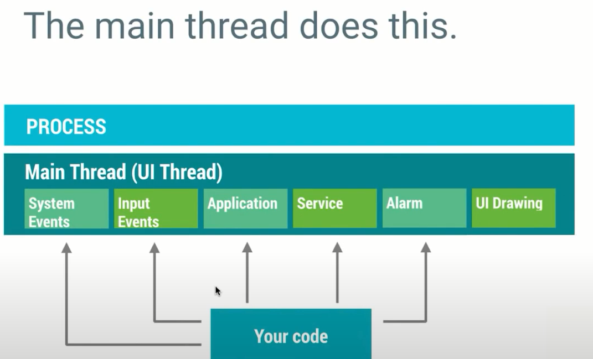

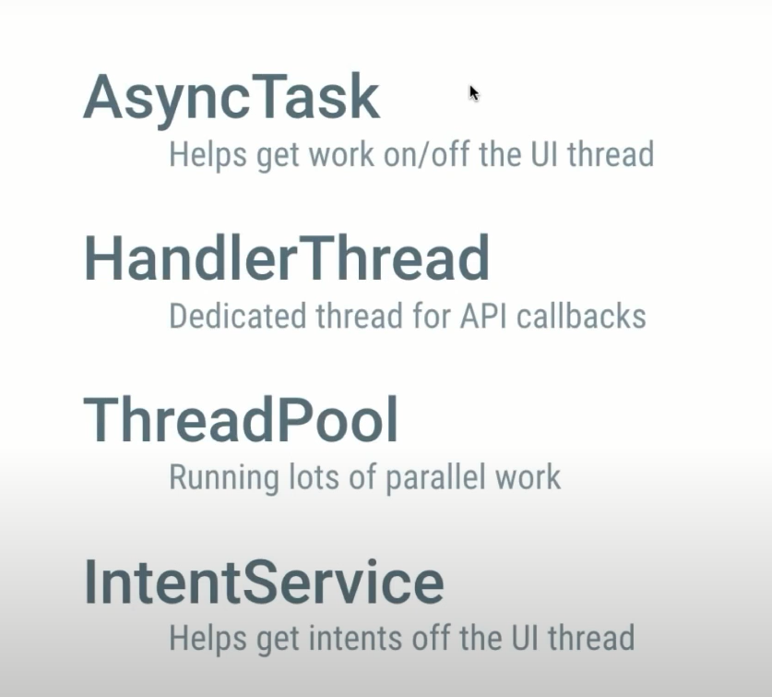

A thread can have one of the following states during its lifetime:

New: In this state, a Thread class object is created using a new operator, but the thread is not alive. Thread doesn't start until we call the start() method.

Runnable: In this state, the thread is ready to run after calling the start() method. However, the thread is not yet selected by the thread scheduler.

Running: In this state, the thread scheduler picks the thread from the ready state, and the thread is running.

Waiting/Blocked: In this state, a thread is not running but still alive, or it is waiting for the other thread to finish.

Dead/Terminated: A thread is in terminated or dead state when the run() method exits.

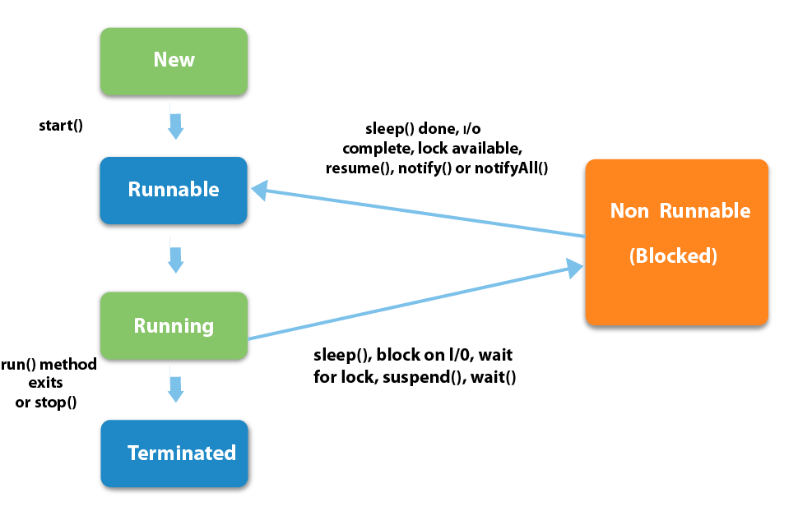

There are two ways to create a thread:

1. By extending Thread class
2. By implementing Runnable interface.

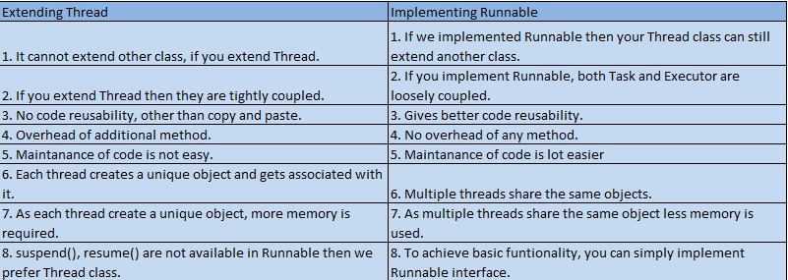

11) Differentiate between the Thread class and Runnable interface for creating a Thread?

The Thread can be created by using two ways.

By extending the Thread class

By implementing the Runnable interface

However, the primary differences between both the ways are given below:

By extending the Thread class, we cannot extend any other class, as Java does not allow multiple inheritances while implementing the Runnable interface; we can also extend other base class(if required).

By extending the Thread class, each of thread creates the unique object and associates with it while implementing the Runnable interface; multiple threads share the same object

Thread class provides various inbuilt methods such as getPriority(), isAlive and many more while the Runnable interface provides a single method, i.e., run().

Why is multithreading important?

Multiple threads can execute concurrently.

Modern Android devices have multiple cores.

The UI is managed in the main thread.

Long-running operations can freeze the UI.

N/W requests are prohibited on the main thread.

When we click on the Android Application it creates a Linux process, which launches the main thread(UI thread)

The main thread in Android is built with a Looper and Handlers.

**What is Architecture?**

If you are building an application in an organized manner with some set of rules, describe proper functionalities and implement it with proper protocols, then it is called an Architecture.

**NEED OF ARCHITECTURE**

• Scalability & Maintainability of an application.

Scalability: - can add new features over a period of time easily

Maintainability: - can do changes in existing features easily without affecting other layers

E.g. Changes done in UI layer should not affect in Model layer

• To achieve this - we implement architecture patterns - MVC, MVP, MVVM etc.

**Architecture patterns mainly focuses on -**

- Separation Of Concerns

Application divided into different components, each component has its own responsibility

- Unit Testing

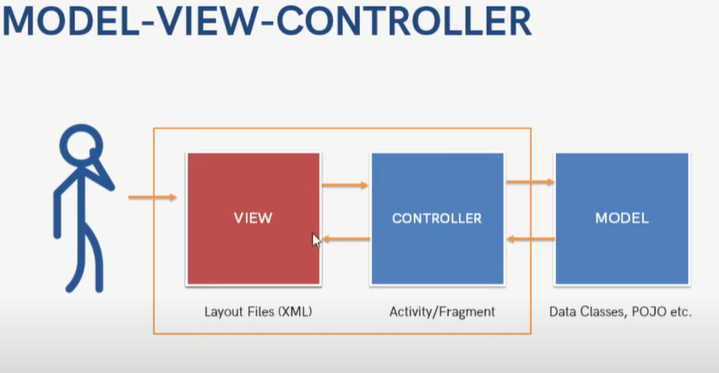

MVC is a simple architecture pattern, its most commonly used architecture in android (default architecture)

Model: It contains all DB and business logic related work. Getting and manipulating the data, communicates with the controller, interacts with the database, its independent unit testing can perform easily on model

View: It contains all layout xml files, it cannot directly interact with model layer, is always use controller

Controller: Its Activity & Fragment, it communicates with view and model, events handling done in controller,

**Advantages**

For small Apps we can use MVC

It keeps business logic separate in the model.

Support asynchronous techniques

The modification does not affect the entire model

Faster development process

**Disadvantages**

Not good for large Apps as View & Controller is tightly coupled, Separation of Concerns is properly followed as View is dependent on Controller, Difficult to create Test Cases for controller.

Due to large code controller is unmanageable.

Increased Complexity

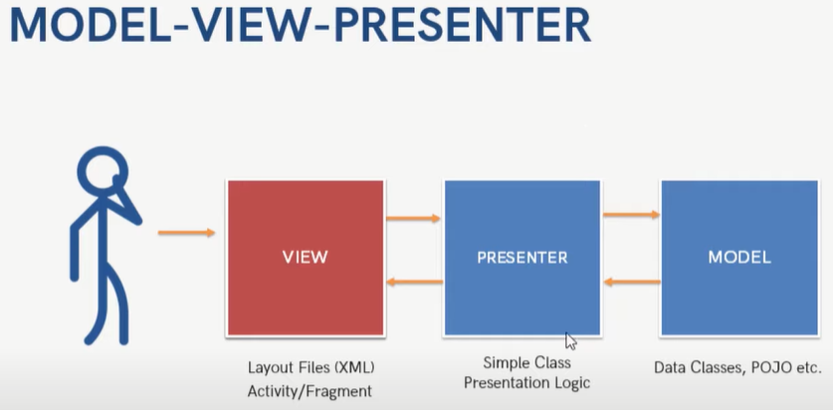

Presenter: Presenter layer can communicate with View using interfaces,

Most of the Android App uses MVP

All components are independent in MVP

**Advantages**

It makes view dumb so that you can swap the view easily.

Reusable of View and Presenter

Code is more readable and maintainable

Easy testing as business logic separated from UI

**Disadvantages**

Huge amount of interfaces for interaction between layers.

The code size is quite excessive.

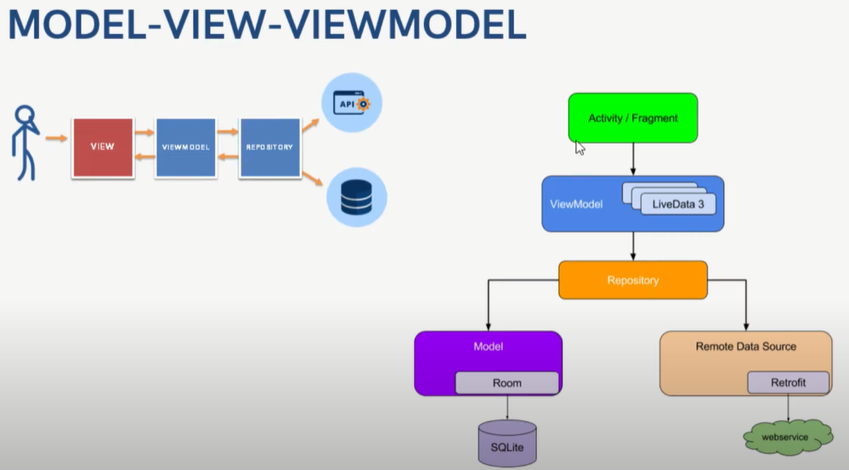

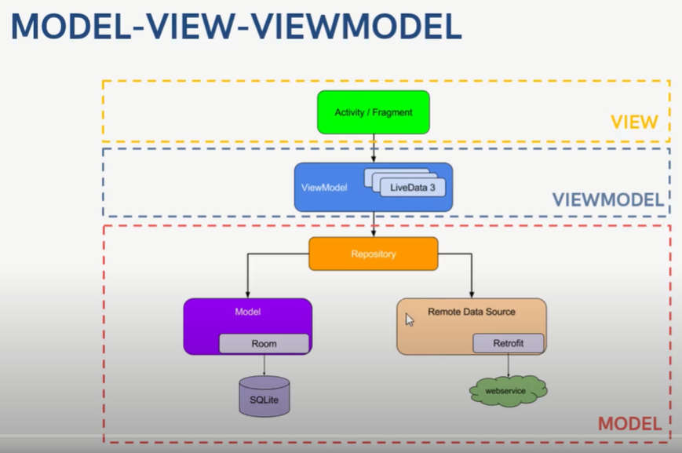

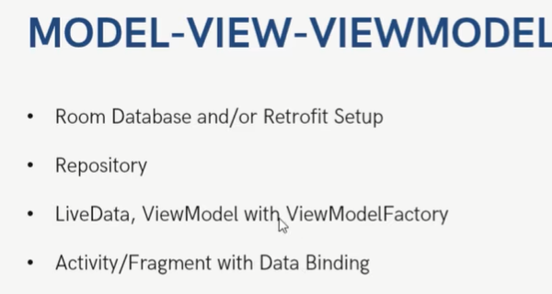

Google recommends MVVM pattern to use

It is a Model-View-ViewModel. It losses the tight coupling between each component and reduces the glue classes. Works on the concept of observables. Children don't have reference to the parent, they only have reference by observables.

Model- It has business logic, local and remote data source and repository. Repository: communicate with local or remote data sources according to the request from ViewModel.  
View- Only user interaction i.e.XML, no business logic. Direct send user action to view model but does not directly get a response. To get a response view observes some data which ViewModel exposes.  
ViewModel- Most of the user interface logic center it here. It is a bridge between a view and a business logic. It does not have any clue which view has to use it. As it does not have a direct reference to the view. Thus, good in testing and has loose coupling. But still, it needs to update the UI this interaction done by observables. When data changes observable notifies.

Advantages

No tight coupling between the view and view model

No interfaces between view and model.

Easy to unit testing and code is event-driven.

Disadvantage

You have to create observables for each UI component.

The code size is quite excessive.

#### **What is Android Jetpack?**

Android Jetpack is a collection of Android software components, Android Jetpack Components are a collection of libraries, tools that help in developing robust android applications

This software components have been divided into 4 categories:

* Foundation Components
* Architecture Components
* Behaviour Components
* UI Components

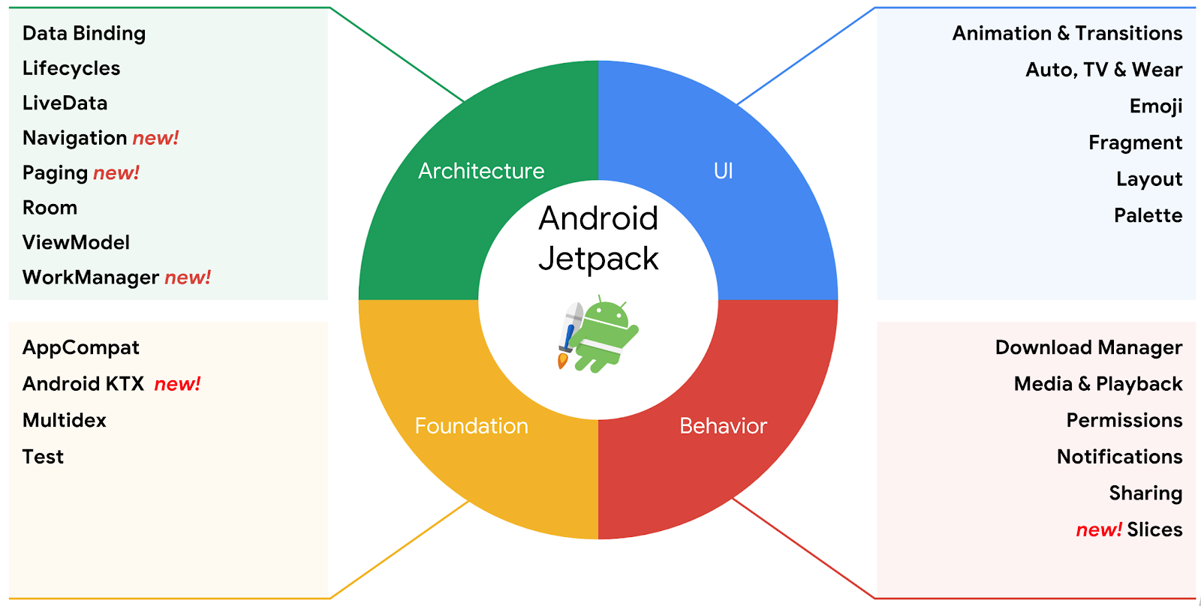

#### **Foundation Components**

The foundation components provide the following:

* Backward compatibility
* Testing
* Kotlin language support.

All the foundation components are as follows:

* [App Compat](https://developer.android.com/topic/libraries/support-library/packages#v7-appcompat): Degrade gracefully on older versions of Android with material design user interface implementation support.
* [Android KTX](https://developer.android.com/kotlin/ktx): Set of Kotlin extensions to write more concise, idiomatic Kotlin code.
* [Multidex](https://developer.android.com/studio/build/multidex): Provide support for multiple dex files for apps.
* [Test](https://developer.android.com/training/testing/): A testing framework for unit and runtime UI tests in Android.

#### [**Architecture Components**](https://blog.mindorks.com/what-are-android-architecture-components)

The architecture components help us in building:

* Robust Apps
* Testable Apps
* Maintainable Apps

All the architecture components are as follows:

* [Data Binding](https://developer.android.com/topic/libraries/data-binding/): Declaratively bind UI elements to in our layout to data sources of our app.
* [Lifecycles](https://developer.android.com/topic/libraries/architecture/lifecycle): Manages activity and fragment lifecycles of our app.
* [LiveData](https://developer.android.com/topic/libraries/architecture/livedata): Notify views of any database changes.
* [Navigation](https://developer.android.com/topic/libraries/architecture/navigation/): Handle everything needed for in-app navigation.
* [Paging](https://developer.android.com/topic/libraries/architecture/paging/): Gradually load information on demand from your data source.
* [Room](https://developer.android.com/topic/libraries/architecture/room): Fluent SQLite database access.
* [ViewModel](https://developer.android.com/topic/libraries/architecture/viewmodel): Manage UI-related data in a lifecycle-conscious way.
* [WorkManager](https://developer.android.com/topic/libraries/architecture/workmanager/): Manage every background jobs in Android with the circumstances we choose.

#### **Behavior Components**

The behavior components help in the integration with standard Android services like

* Download Manager
* Notifications
* Permissions
* Sharing

All the behavior components are as follows:

* [Download Manager](https://developer.android.com/reference/android/app/DownloadManager): Schedule and manage large downloads in background with auto retry support.
* [Media & playback](https://developer.android.com/guide/topics/media-apps/media-apps-overview): Backwards compatible APIs for media playback and routing (including Google Cast).
* [Notifications](https://developer.android.com/guide/topics/ui/notifiers/notifications): Provides a backwards-compatible notification API with Wear and Auto support.
* [Permissions](https://developer.android.com/guide/topics/permissions/overview): Compatibility APIs for checking and requesting permissions in app.
* [Preferences](https://developer.android.com/guide/topics/ui/settings): Create interactive settings screens for users to configure.
* [Sharing](https://developer.android.com/training/sharing/shareaction): Provides a share action suitable for an app’s action bar.
* [Slices](https://developer.android.com/guide/slices): Create flexible UI elements that can display app data outside the app and can be extended all the way back to Android 4.4.

#### **UI Components**

The UI components provide widgets and helpers to make your app not only easy, but delightful to use.

All the UI components are as follows:

* [Animation and transitions](https://developer.android.com/training/animation/): Move widgets and transition between screens.
* [Auto](https://developer.android.com/auto): Components to develop Android Auto apps.
* [Emoji](https://developer.android.com/guide/topics/ui/look-and-feel/emoji-compat): Enable updated emoji font on older platforms.
* [Fragment](https://developer.android.com/guide/components/fragments): A basic unit of composable UI.
* [Layout](https://developer.android.com/guide/topics/ui/declaring-layout): Lay out widgets with different algorithms.
* [Palette](https://developer.android.com/training/material/palette-colors): Pull useful information from color palettes.
* [TV](https://developer.android.com/tv/): Components to develop Android TV apps.
* [Wear](https://developer.android.com/wear/): Components to develop Wear apps.

|  |  |
| --- | --- |
| DALVIK VIRTUAL MACHINE | ANDROID RUN TIME |
| **Dalvik used Just-In-Time (JIT) approach** in which the compilation was done on demand. | **ART uses the Ahead-Of-Time (AOT) approach**, in which the dex files were compiled before they were demanded. |
| Dalvik, whenever you touch an app icon to open it, the necessary dex files gets converted into their equivalent native codes. The app will only start working when this compilation is done | ART, whenever you install an app, **all the dex files gets converted once and for all**. So the installation takes some time and the app takes more space than in Dalvik |
| Faster Booting time | Rebooting is significantly longer |
| Cache builds up overtime | The cache is built during the first boot |
| Occupies less space due to JIT | Consumes a lot of storage space internally due to AOT |
| Works best for small storage devices | Works best for Large storage devices |
| Stable and tested virtual machine | Experimental and new – not much app support comparatively |
| Longer app loading time | Extremely Faster and smoother Faster and app loading time and lower processor usage |
| Uses JIT compiler(JIT: Just-In-Time) Thereby resulting in lower storage space consumption | Uses AOT compiler(Ahead-Of-Time) thereby compiling apps when installed |
| Application lagging due to garbage collector pauses and JIT | Reduced application lagging and better user experience |
| App installation time is comparatively lower as the compilation is performed later | App installation time is longer as compilation is done during installation |
| DVM converts bytecode every time you launch a specific app. | ART converts it just once at the time of app installation. That makes CPU execution easier.  Improved battery life due to faster execution. |

# Android RecyclerView List Example

The RecyclerView class extends the ViewGroup class and implements ScrollingView interface. It is introduced in Marshmallow. It is an advanced version of the ListView with improved performance and other benefits. RecyclerView is mostly used to design the user interface with the fine-grain control over the lists and grids of android application.

For each Item we have a view. But if we create a view for each item in ONE GO then we have 500 views but user can see only 10-15 views at a time. Memory wastage

The major components of RecyclerView are,

Adapter

ViewHolder

LayoutManager

**The Adapter:**

This will adapt our data so that in can be displayed in list.

Adapter is a bridge b/w UI components and data source that help us to fill data in UI components. adapter is the main code responsible for RecyclerView. It holds all the important methods dealing with the implementation of RecylcerView. The basic methods for a successful implementation are:

* *onCreateViewHolder*: which deals with the inflation of the card layout as an item for the RecyclerView.
* *onBindViewHolder*: which deals with the setting of different data and methods related to clicks on particular items of the RecyclerView.
* *getItemCount*: which Returns the length of the RecyclerView.
* *onAttachedToRecyclerView*: which attaches the adapter to the RecyclerView.

**The ViewHolder:** This will hold the view and helps in recycling

The ViewHolder is a java class that stores the reference to the card layout views that have to be dynamically modified during the execution of the program by a list of data obtained either by online databases or added in some other way.

Steps:

0. Add RecyclerView support library **com.android.support:recyclerview-v7:23.1.0** or above this version in build.gradle file.

1. In the **activity_main.xml** file in layout directory, add the RecyclerView widget.

2. Create a custom layout **list_item.xml** file

3. Create a **MyListAdapter.java** class

This class extends *RecyclerView.Adapter* class and override its unimplemented methods. The onCreateViewHolder() methods inflates the *list_item.xml*. In the onBindViewHolder() method each data items are set to each row.

4. Finally, in the **MainActivity.java** class

**Design patterns: -**

Design patterns is basically a solution or blueprint for a problem that we get over and over again in programming, so they are just typical types of problems we can encounter as programmers, and these design patterns are just a good way to solve those problems, there is a lot of design pattern in android. So basically, they are three categories as below:

1. **Creational pat terns**: How you create objects.
2. **Structural patterns**: How you compose objects.
3. **Behavioral patterns**: How you coordinate object interactions.

### 1. Creational Patterns

These are the design patterns that deal with object creation mechanisms, trying to create objects in a manner suitable to the situation. The basic form of object creation could result in design problems or added complexity to the design. Creational design patterns solve this problem by somehow controlling this object creation.

These are the design patterns are come under this category.

* Singleton
* Builder
* Dependency Injection
* Factory

[**Singleton**](https://www.geeksforgeeks.org/singleton-design-pattern/)**:**

* The singleton pattern ensures that only one object of a particular class is ever created. All further references to objects of the singleton class refer to the same underlying instance. There are very few applications, do not overuse this pattern.
* It’s very easy to accomplish in Kotlin but not in java. because in java there is no native implementation of the singleton.

Singleton Design pattern - Implementation

• Constructor should be private A

• Public method for returning instance

• Instance type - private static

Initialisation Type:

• Eager Initialisation

• Lazy Initialisation

• Thread safe Method Initialisation

• Thread safe block Initialisation

https://www.geeksforgeeks.org/design-patterns-in-android-with-kotlin/

**Room Database**

• Entities (Tables)

• DAO (Data Access Objects)

• Database

• Type Convertors

• Migrations

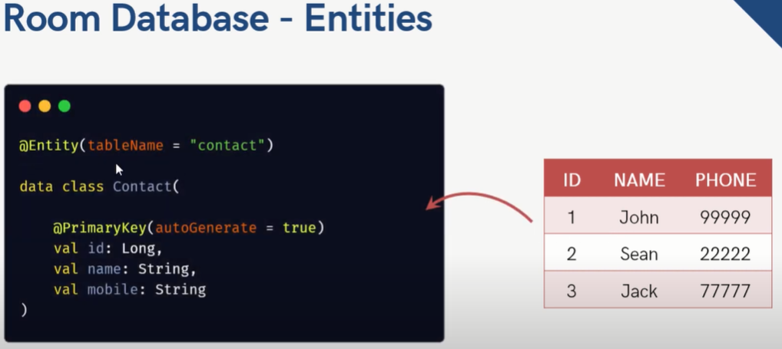

Room Database - DAO

Data Access Objects

Interface containing methods to access database - CRUD Operations

We can define multiple DAOS

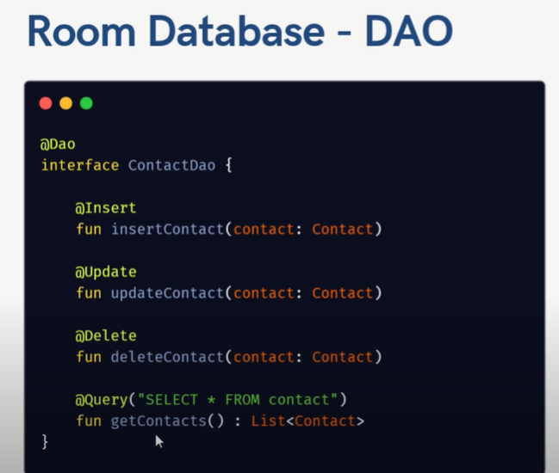

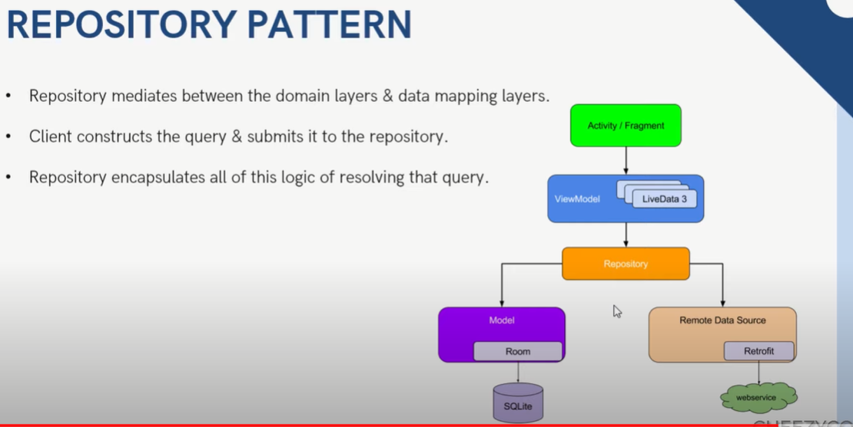

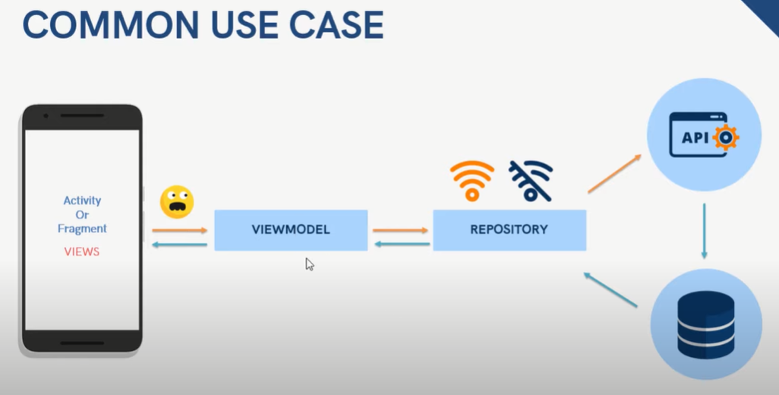

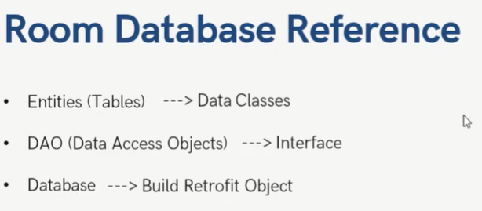

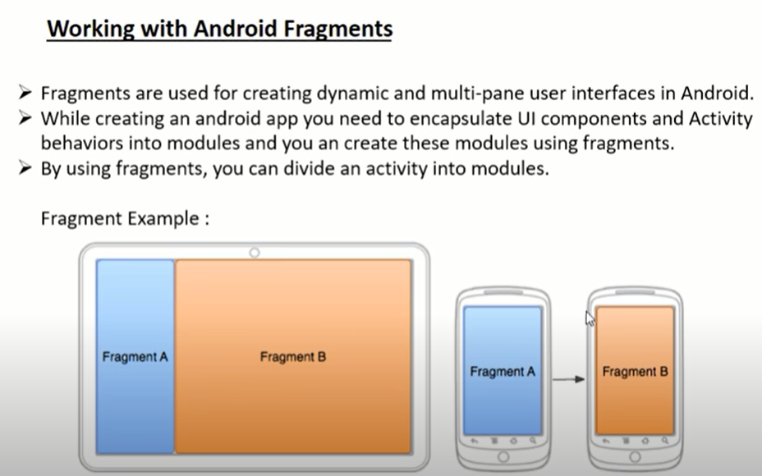

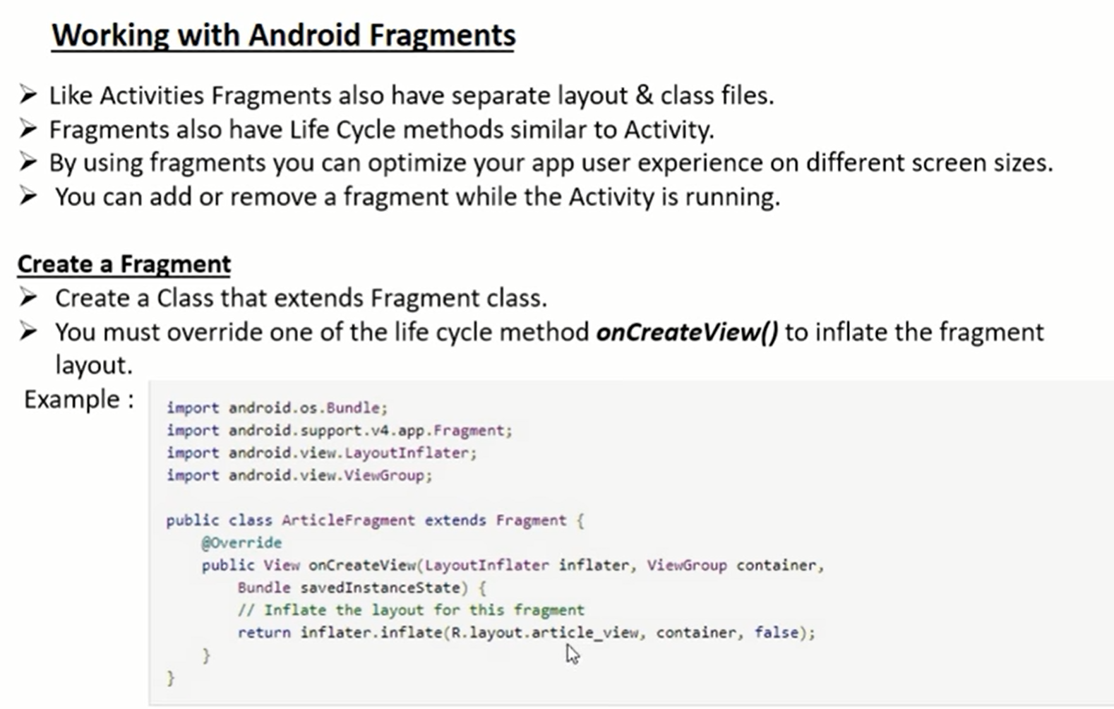

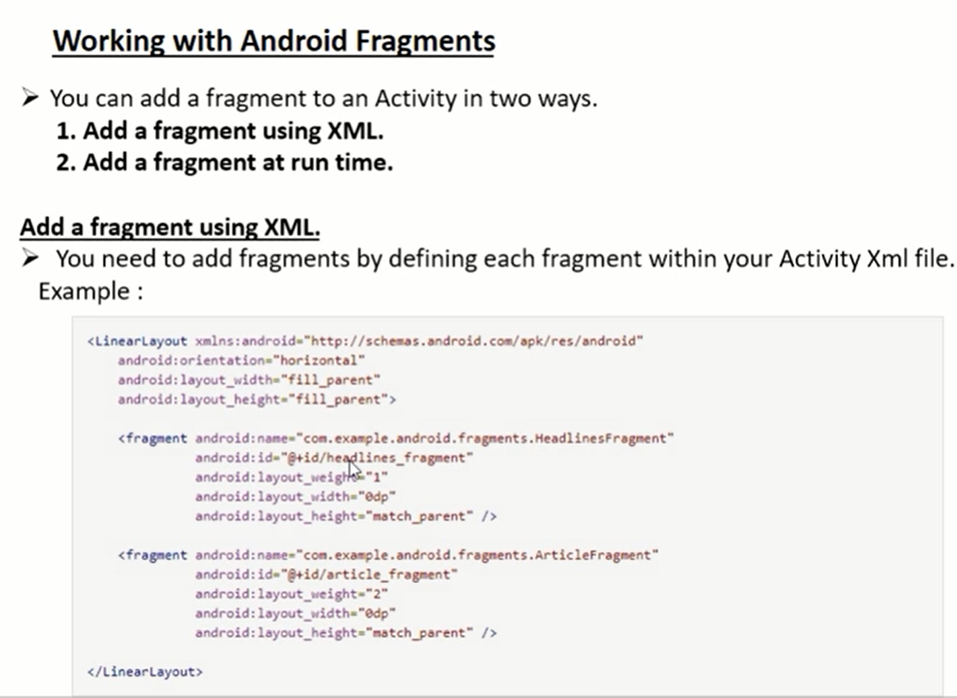

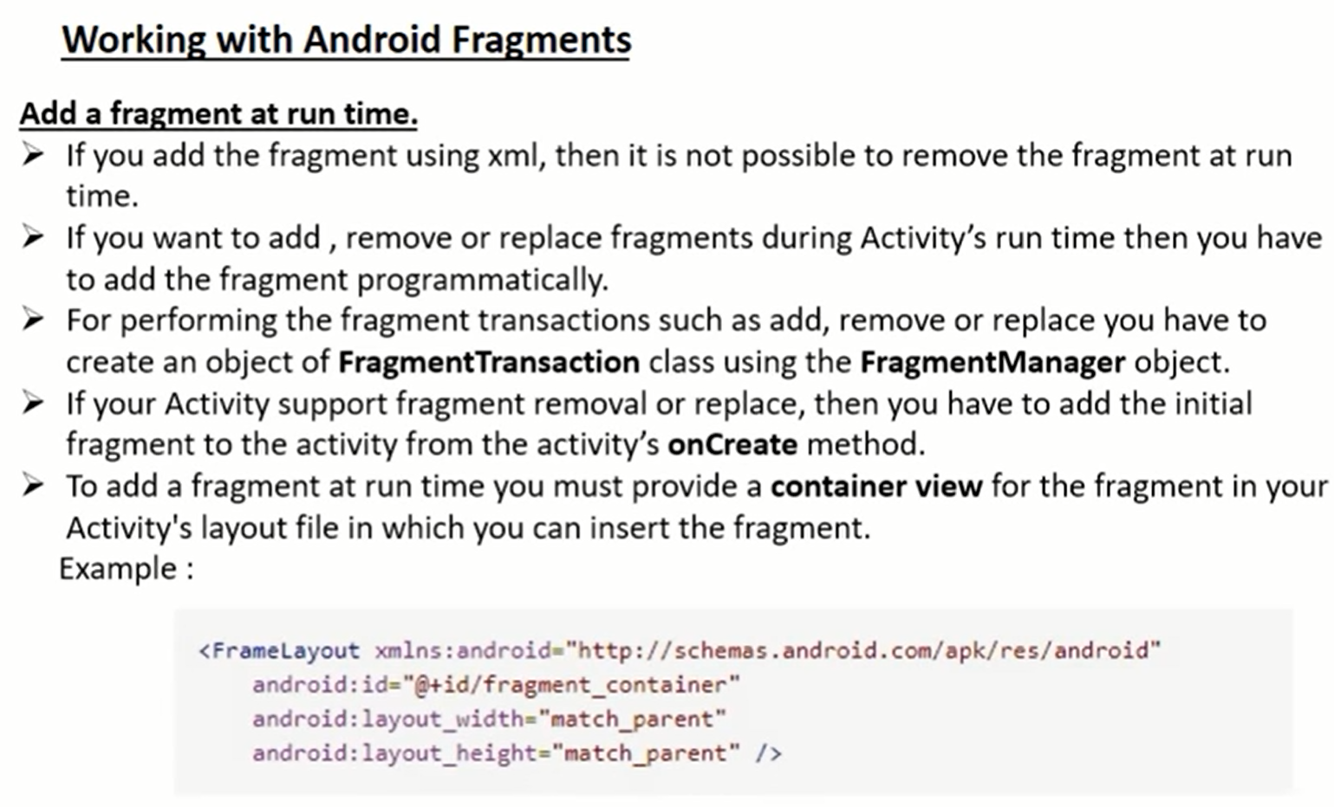

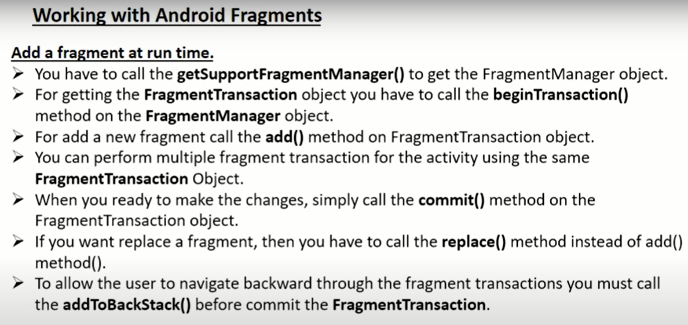

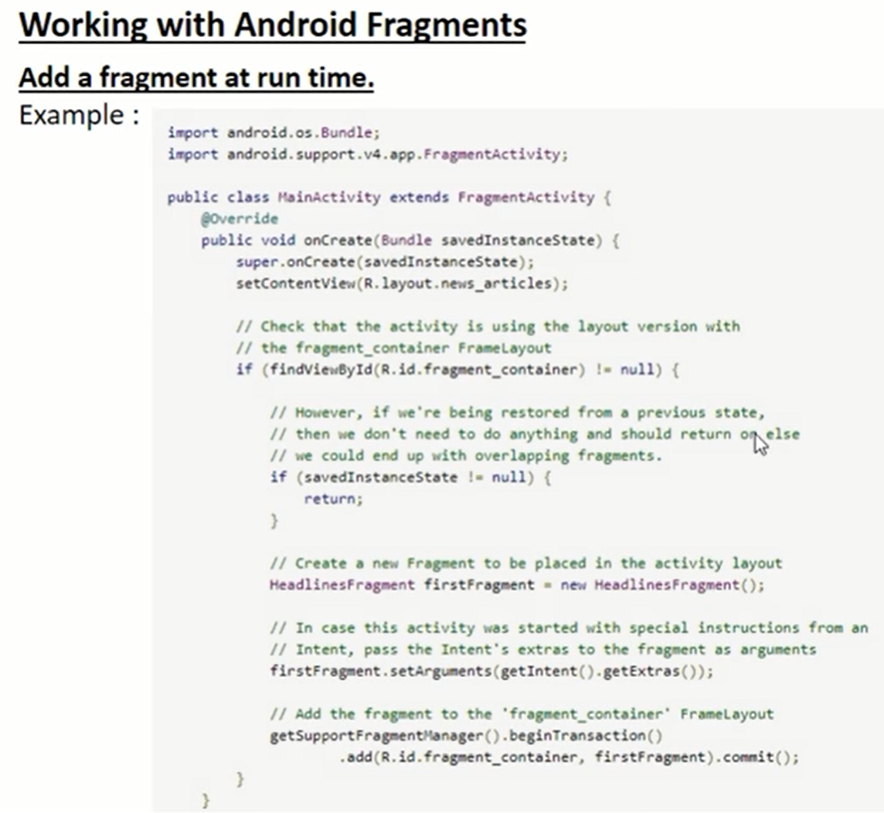

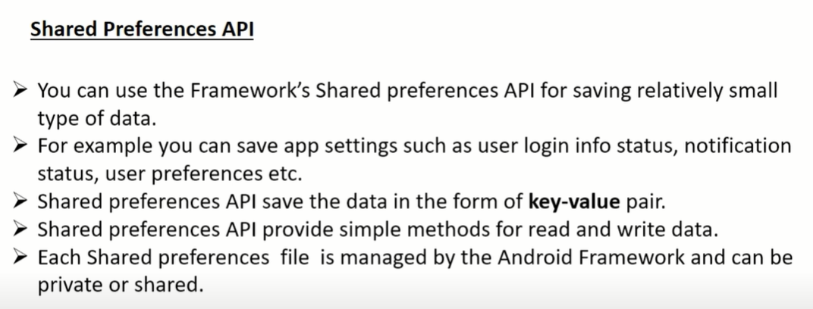

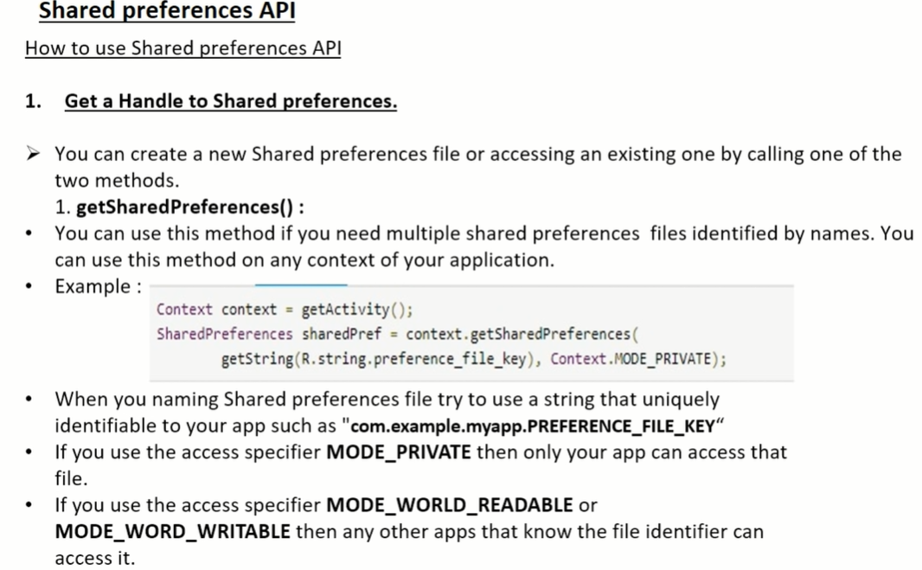

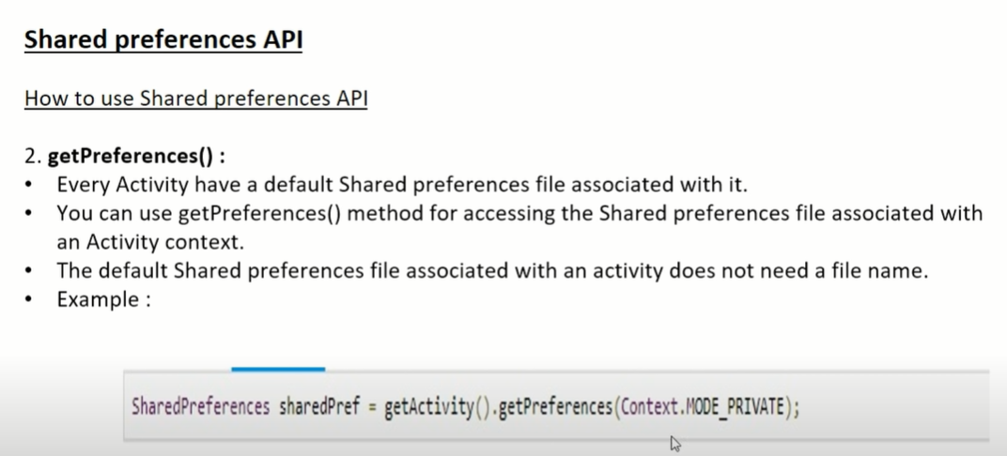

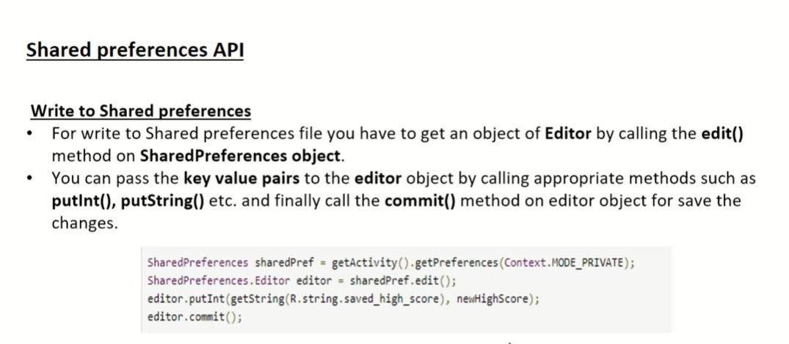

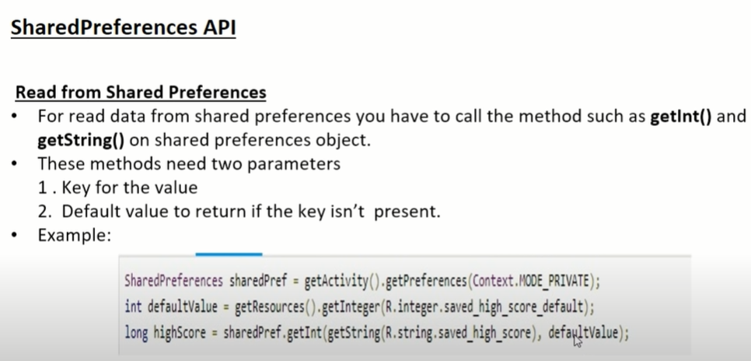

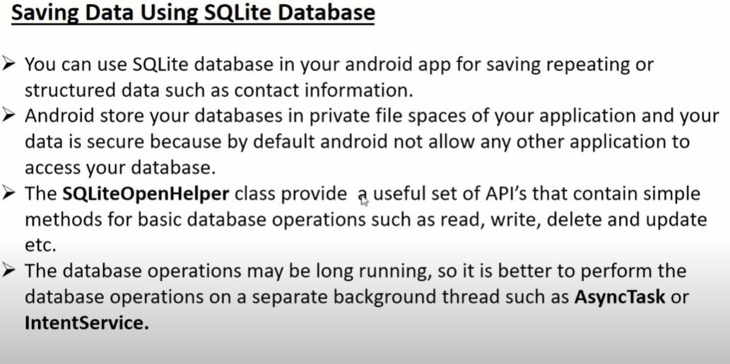

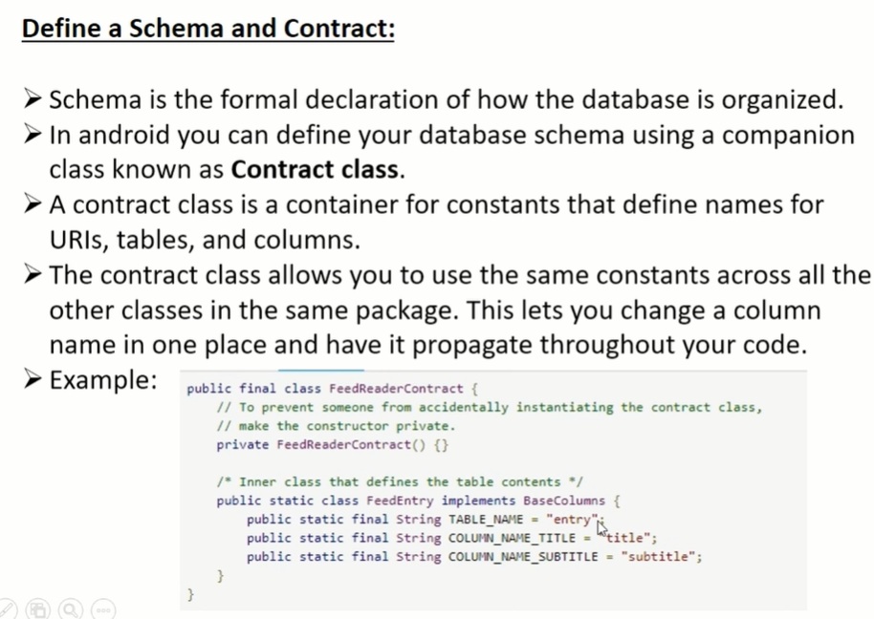

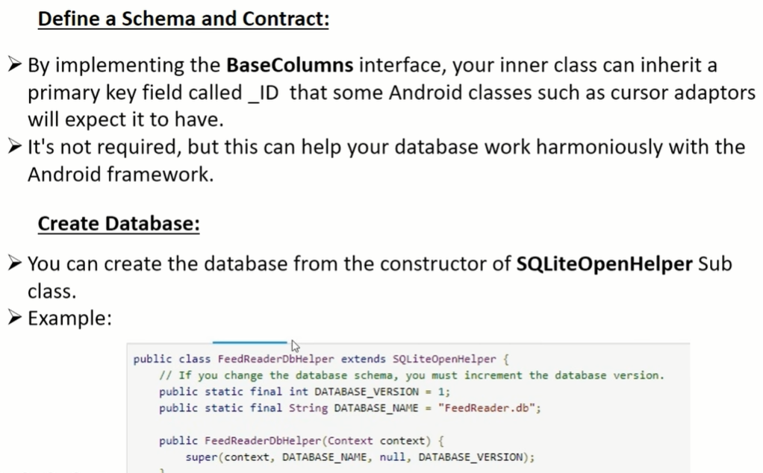

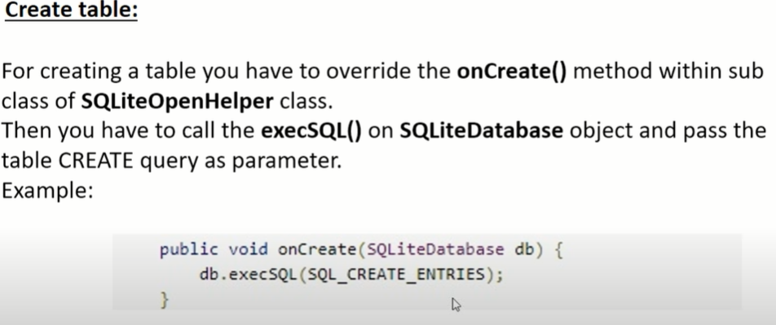

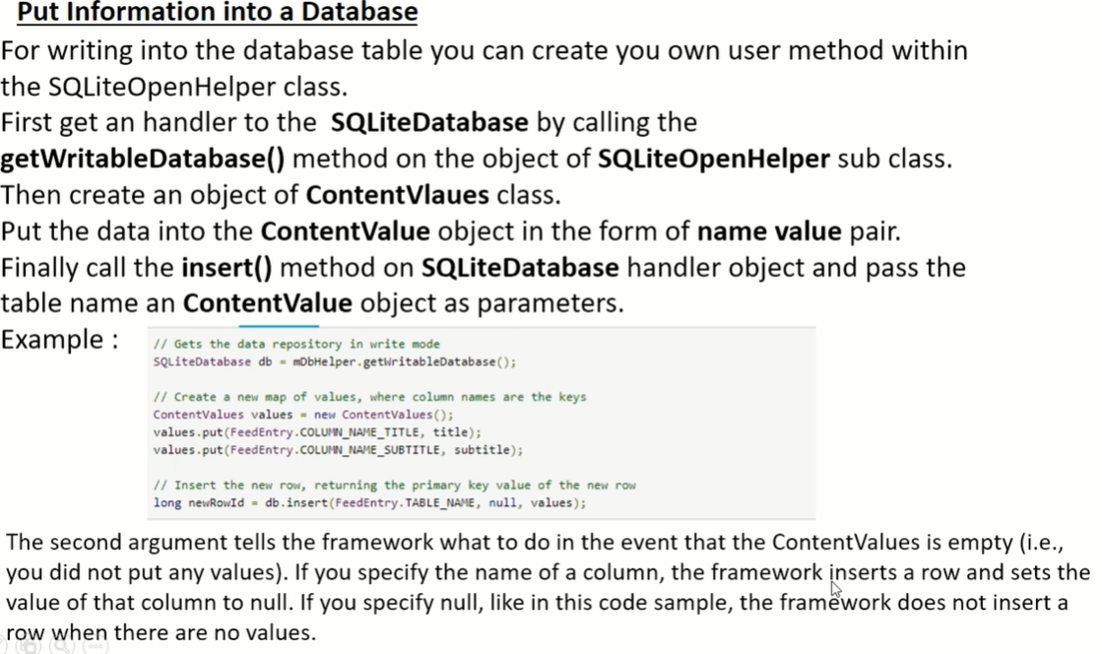

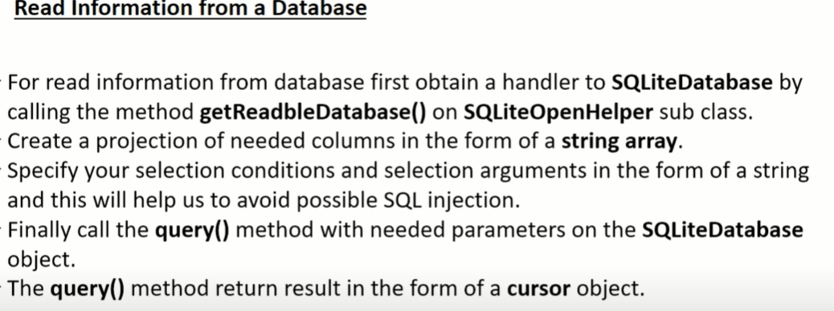

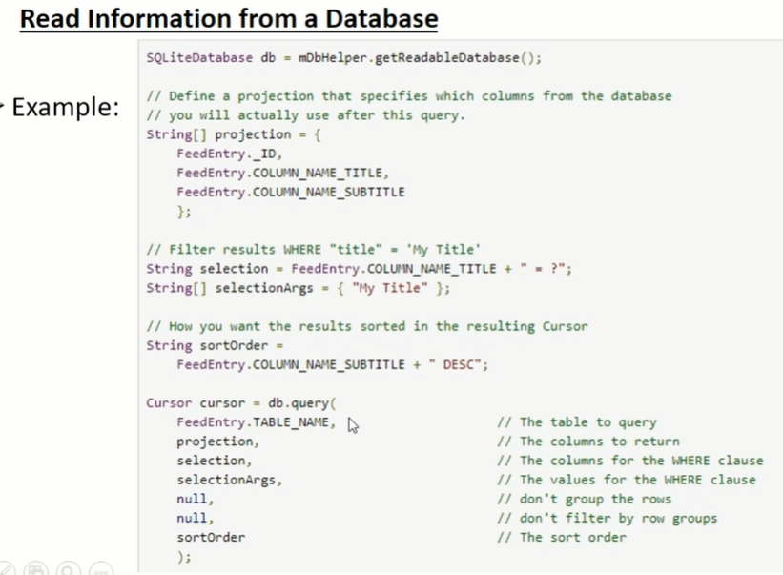

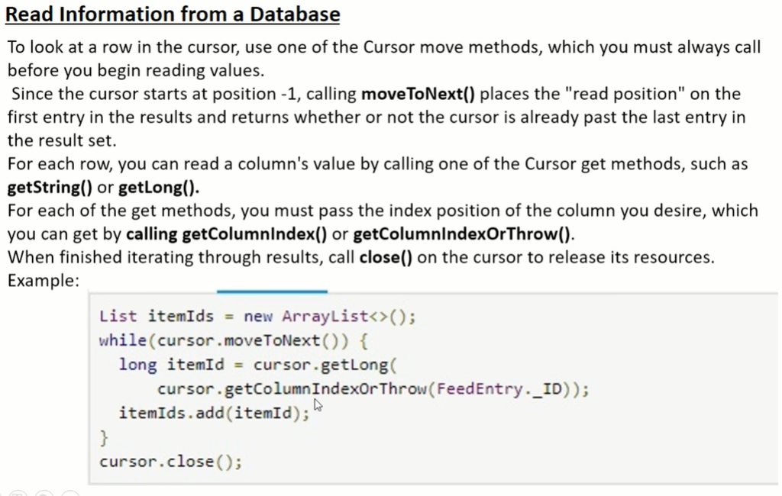

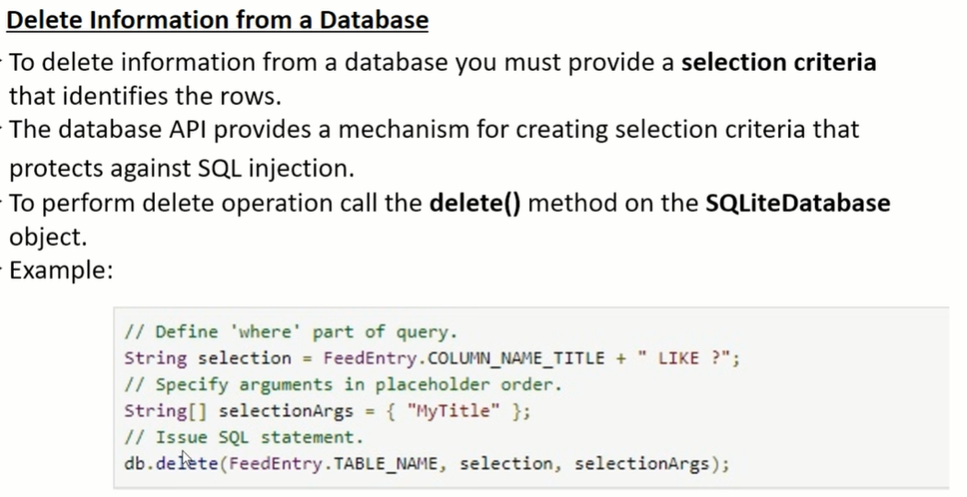

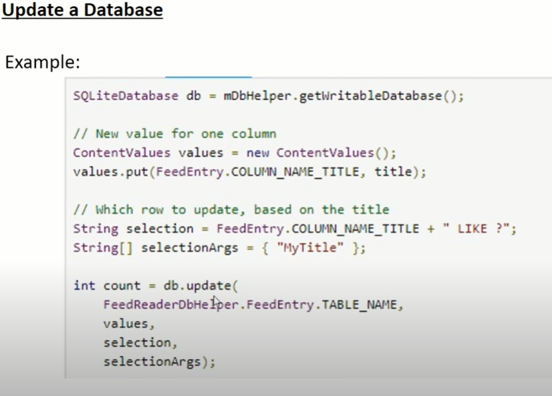

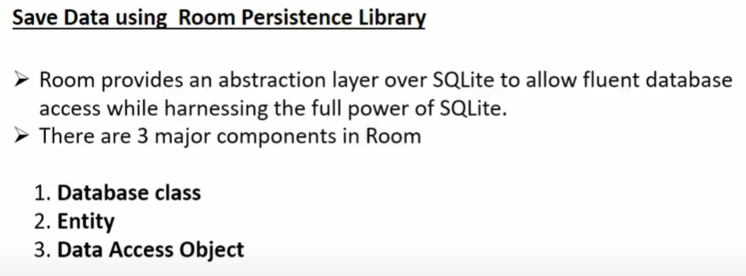

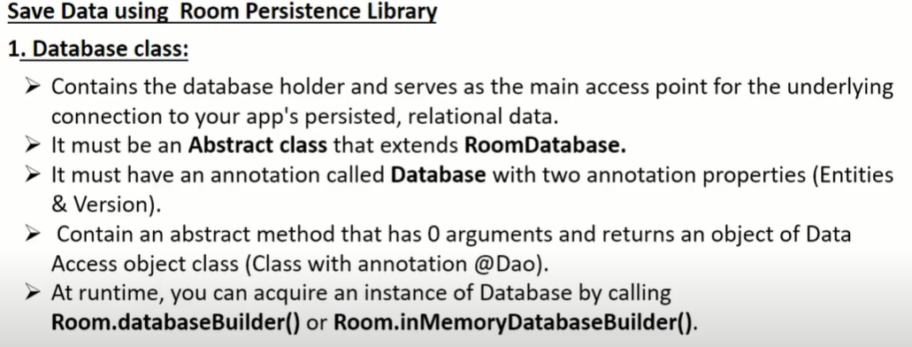

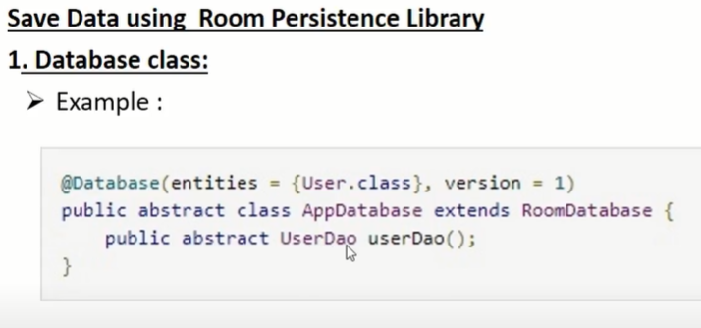

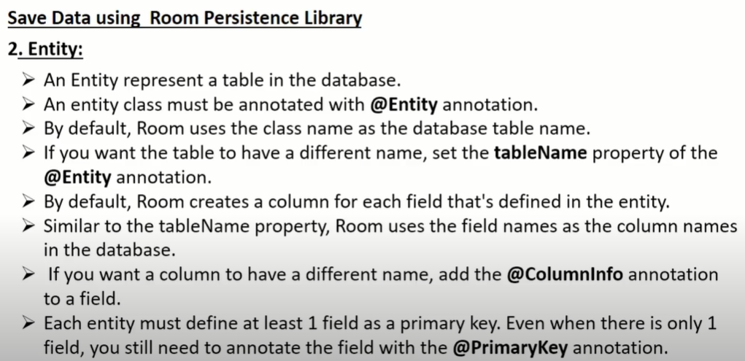

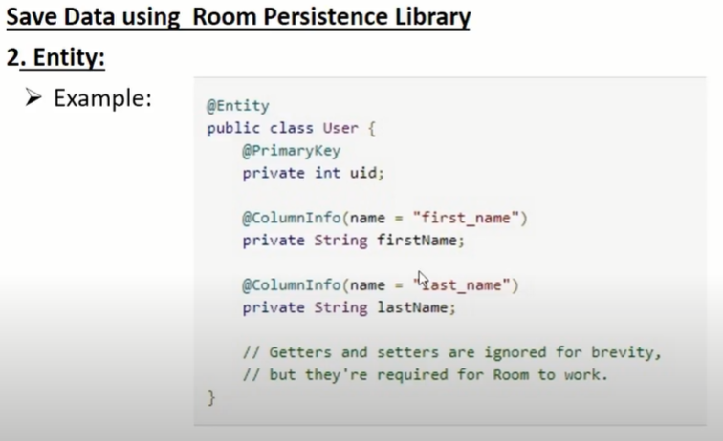

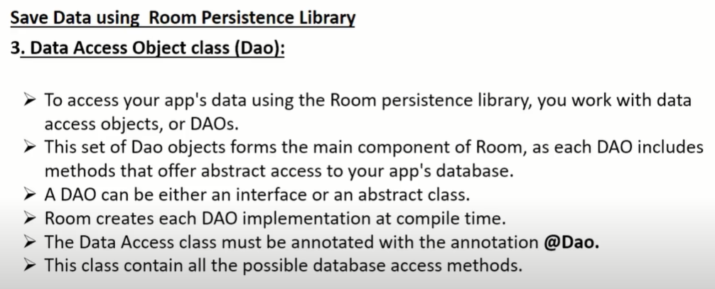

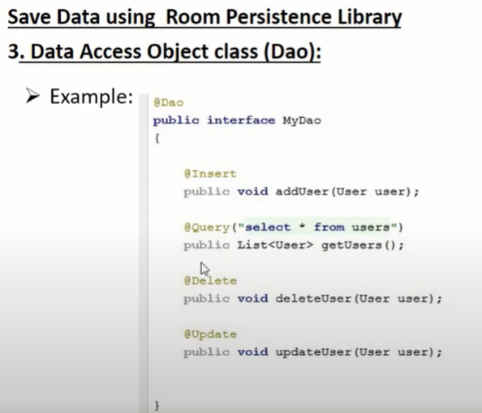

**What is REST API?**

The term REST stands for REpresentational State Transfer. It is an architectural style that defines a set of rules in order to create Web Services. In a client-server communication, REST suggests to create an object of the data requested by the client and send the values of the object in response to the user. For example, if the user is requesting for a movie in Bangalore at a certain place and time, then you can create an object on the server-side.

So, over here, you have an object and you are sending the state of an object. This is why REST is known as Representational State Transfer.

**Principles of REST API**

**Stateless**

The requests sent from a client to a server will contain all the required information to make the server understand the requests sent from the client. This can be either a part of URL, query-string parameters, body, or even headers.

The URL is used to uniquely identify the resource and the body holds the state of the requesting resource. Once the server processes the request, a response is sent to the client through body, status or headers

**Client-Server**

The client-server architecture enables a uniform interface and separates clients from the servers. This enhances the portability across multiple platforms as well as the scalability of the server components.

**Uniform Interface**

To obtain the uniformity throughout the application, REST has the following four interface constraints:

* Resource identification
* Resource Manipulation using representations
* Self-descriptive messages
* Hypermedia as the engine of application state

**Cacheable**

In order to provide a better performance, the applications are often made cacheable. This is done by labeling the response from the server as cacheable or non-cacheable either implicitly or explicitly. If the response is defined as cacheable, then the client cache can reuse the response data for equivalent responses in the future.

**Retrofit**

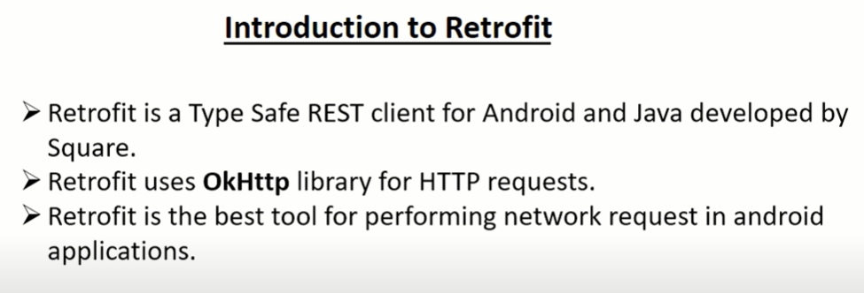

- Library to fetch data from server

- Volley is another library to fetch data,

• It works well with JSON and XML both, Easy to implement

